WOLVERTON AND GREENLEYS TOWN COUNCIL

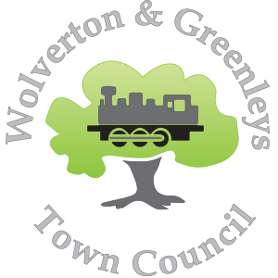

Risk Management Policy

Date Ratified: XXXX
Meeting Full Council XXXXM Minute ref: TCxxx
Next review Date: xxxx

- Policy Aim
The council recognises that it has a responsibility to take all reasonable and practical measures to safeguard its employees, the people it works with and provides services for; and to protect the natural and built environments for which it is responsible as well as being financially responsible for proper use of public funds.

The council is aware that some risks cannot be eliminated fully and has in place a strategy that provides a structured, systematic, and focused approach to managing risk.
- Implementation
Risk management is making sure informed decisions are made based upon facts and the risks identified, which typically are finance and safety. Most risk can be eliminated if the Town Council ensures that it operates according to all relevant rules, legislation, procedures, and codes of conduct appertaining to its functions. Strict adherence to financial disciplines and controls is always of paramount importance.
A risk assessment is a careful examination of all aspects concerning our council’s operations so that an informed decisions can be made knowing that unnecessary risk has been eliminated and any remaining risk together with its impact has been identified.
The risk assessment and management procedures for Wolverton and Greenleys Town Council are outline in the attached risk assessment register where likely hood and impact of risks are assessed on a traffic light basis.
The objectives of the risk management policy are to:
- Integrate risk management into the culture of the council
- Manage risk in accordance with best practice and legislative requirements
- Minimise loss, business disruption, injury, and damages
- Inform policy and operational decisions by identifying risks and impacts
- Raise awareness of the need for risk management

These objectives will be achieved by:

- Undertaking risk assessments for individual areas of work, reviewing at least annually
- Undertaking a whole organisation annual review of the risks assessment register
- Managing the risk and recording actions
- Incorporating risk management considerations into council processes
- Providing appropriate training
- Establishing clear roles, responsibilities, and reporting lines
- Effective communication with, and active involvement of, Councillors, staff, and volunteers

Monitoring
Annually – Full Council risk assessment register
As required but no less than annually – Risk assessment registers for individual activities

